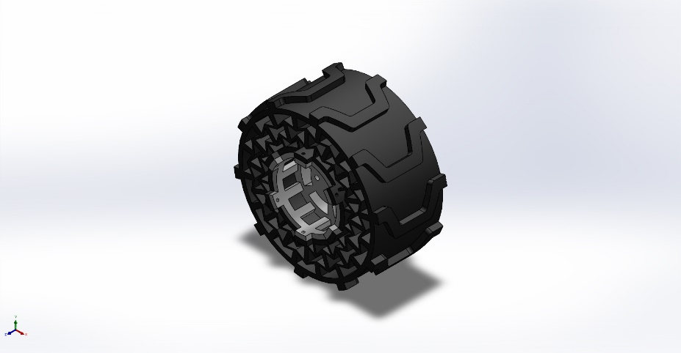
  Simulation of wheel 2.1 assembly
  Date: 08 March 2024
  Designer: Solidworks
  Study name: ultem rim
  Analysis type: Static
  Table of Contents
  Description 1
  Assumptions 2
  Model Information 2
  Study Properties 3
  Units 3
  Material Properties 4
  Loads and Fixtures 5
  Connector Definitions 5
  Interaction Information 6
  Mesh information 6
  Sensor Details 6
  Resultant Forces 7
  Beams 7
  Study Results 8
  Conclusion 10

Description
No Data

Assumptions

Model Information

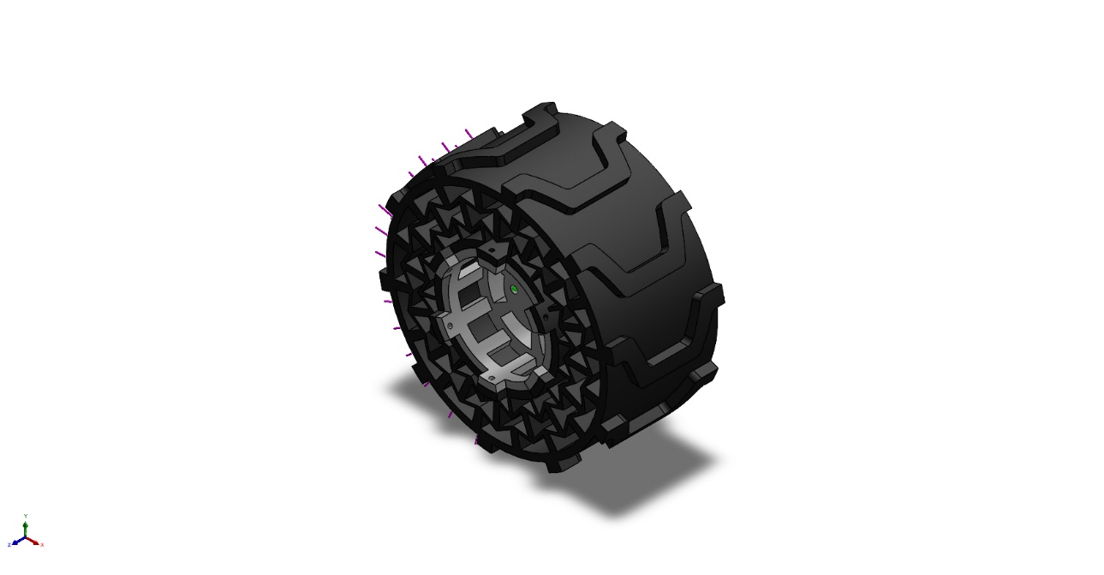
Model name: wheel 2.1 assembly
Current Configuration: Default
Solid Bodies
Document Name and Reference | Treated As | Volumetric Properties | Document Path/Date Modified
Mirror2  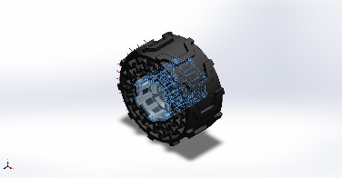 | Solid Body | Mass:0.183831 kg  Volume:0.000145007 m^3  Density:1,267.74 kg/m^3  Weight:1.80155 N | H:\Priyo H\Study\JU-IAR\URSC\designs\New Designs\rim2.SLDPRT  Mar 8 21:53:43 2024
Mirror1  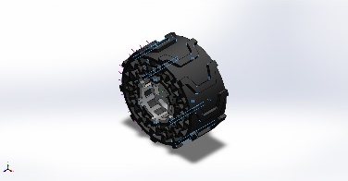 | Solid Body | Mass:0.871134 kg  Volume:0.000714044 m^3  Density:1,220 kg/m^3  Weight:8.53712 N | H:\Priyo H\Study\JU-IAR\URSC\designs\New Designs\wheel 2.1.SLDPRT  Mar 3 17:17:31 2024

Study Properties
Study name | ultem rim
Analysis type | Static
Mesh type | Solid Mesh
Thermal Effect: | On
Thermal option | Include temperature loads
Zero strain temperature | 298 Kelvin
Include fluid pressure effects from SOLIDWORKS Flow Simulation | Off
Solver type | Automatic
Inplane Effect: | Off
Soft Spring: | Off
Inertial Relief: | Off
Incompatible bonding options | Automatic
Large displacement | Off
Compute free body forces | On
Friction | Off
Use Adaptive Method: | Off
Result folder | SOLIDWORKS document (H:\Priyo H\Study\JU-IAR\URSC\designs\New Designs)

Units
Unit system: | SI (MKS)
Length/Displacement | mm
Temperature | Kelvin
Angular velocity | Rad/sec
Pressure/Stress | N/m^2

Material Properties
Model Reference | Properties | Components
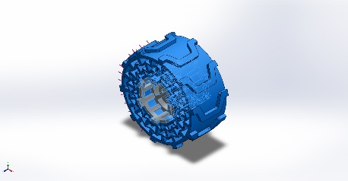 |  | SolidBody 1(Mirror2)(rim2-1)
  Name: | ULTEM
  Model type: | Linear Elastic Isotropic
  Default failure criterion: | Unknown
  Yield strength: | 1.64785e+08 N/m^2
  Tensile strength: | 1.15142e+08 N/m^2
  Compressive strength: | 1.34448e+08 N/m^2
  Elastic modulus: | 3.50943e+09 N/m^2
  Poisson's ratio: | 0.36
  Mass density: | 1,267.74 kg/m^3
  Thermal expansion coefficient: | 4.68e-05 /Kelvin
Curve Data:N/A
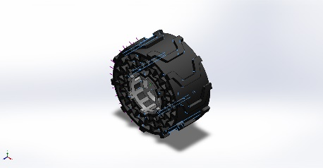 |  | SolidBody 1(Mirror1)(wheel 2.1-1)
  Name: | TPU
  Model type: | Linear Elastic Isotropic
  Default failure criterion: | Unknown
  Tensile strength: | 2.62001e+07 N/m^2
  Elastic modulus: | 2.41e+09 N/m^2
  Poisson's ratio: | 0.3897
  Mass density: | 1,220 kg/m^3
  Shear modulus: | 8.622e+08 N/m^2
Curve Data:N/A

Loads and Fixtures
Fixture name | Fixture Image | Fixture Details
Fixed-1 | 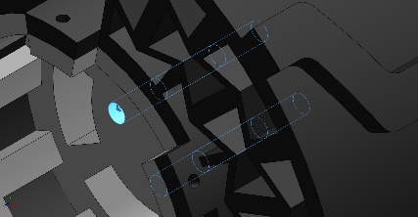
  Entities: | 4 face(s)
  Type: | Fixed Geometry
Resultant Forces
Components | X | Y | Z | Resultant
Reaction force(N) | -157.656 | -59.3996 | 0.000354569 | 168.475
Reaction Moment(N.m) | 0 | 0 | 0 | 0

Load name | Load Image | Load Details
Force-1 | 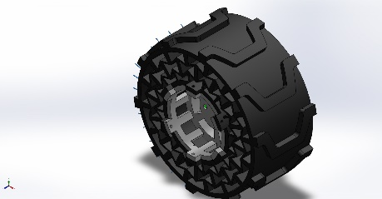
  Entities: | 3 face(s)
  Type: | Apply normal force
  Value: | 20 kgf

Connector Definitions
No Data

Interaction Information

Interaction | Interaction Image | Interaction Properties
Global Interaction | 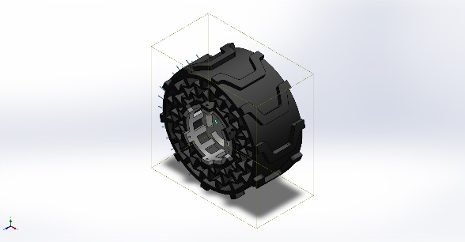
  Type: | Bonded
  Components: | 1 component(s)
  Options: | Independent mesh

Mesh information
Mesh type | Solid Mesh
Mesher Used: | Blended curvature-based mesh
Jacobian points for High quality mesh | 16 Points
Maximum element size | 28.951 mm
Minimum element size | 1.44755 mm
Mesh Quality | High
Remesh failed parts independently | Off

Mesh information - Details
Total Nodes | 72163
Total Elements | 40925
Maximum Aspect Ratio | 73.032
% of elements with Aspect Ratio < 3 | 81.9
Percentage of elements with Aspect Ratio > 10 | 0.342
Percentage of distorted elements | 0
Time to complete mesh(hh;mm;ss): | 00:00:18
Computer name: | URJA

Sensor Details
No Data

Resultant Forces

Reaction forces
Selection set | Units | Sum X | Sum Y | Sum Z | Resultant
Entire Model | N | -157.656 | -59.3996 | 0.000354569 | 168.475

Reaction Moments
Selection set | Units | Sum X | Sum Y | Sum Z | Resultant
Entire Model | N.m | 0 | 0 | 0 | 0

Free body forces
Selection set | Units | Sum X | Sum Y | Sum Z | Resultant
Entire Model | N | 0.0131148 | 0.034775 | 0.00474539 | 0.0374675

Free body moments
Selection set | Units | Sum X | Sum Y | Sum Z | Resultant
Entire Model | N.m | 0 | 0 | 0 | 1e-33

Beams
No Data

Study Results

Name | Type | Min | Max
Stress1 | VON: von Mises Stress | 7.089e+01N/m^2  Node: 53284 | 4.321e+05N/m^2  Node: 71747
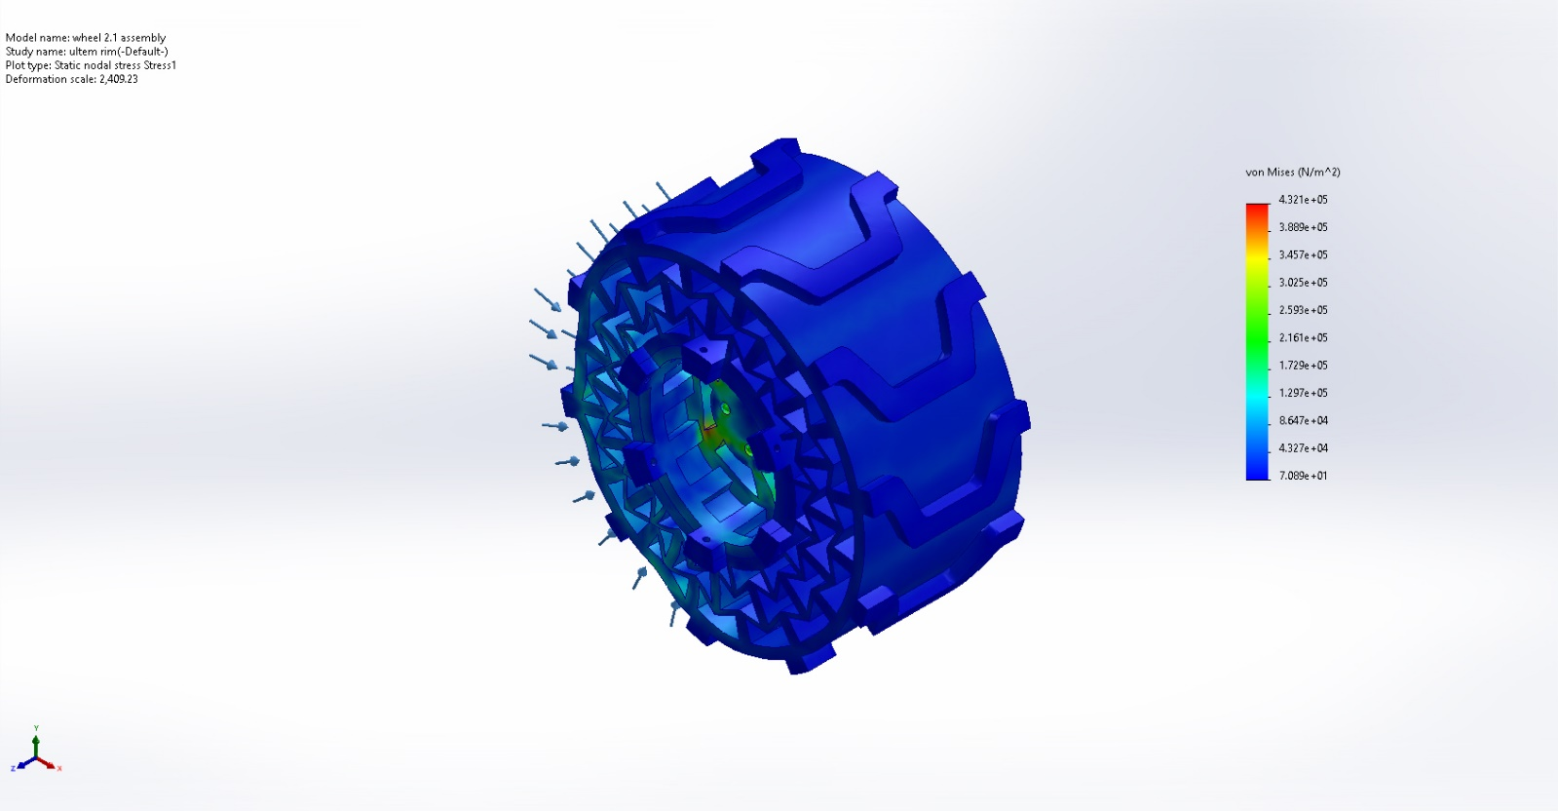
wheel 2.1 assembly-ultem rim-Stress-Stress1

Name | Type | Min | Max
Displacement1 | URES: Resultant Displacement | 0.000e+00mm  Node: 347 | 7.367e-03mm  Node: 31341
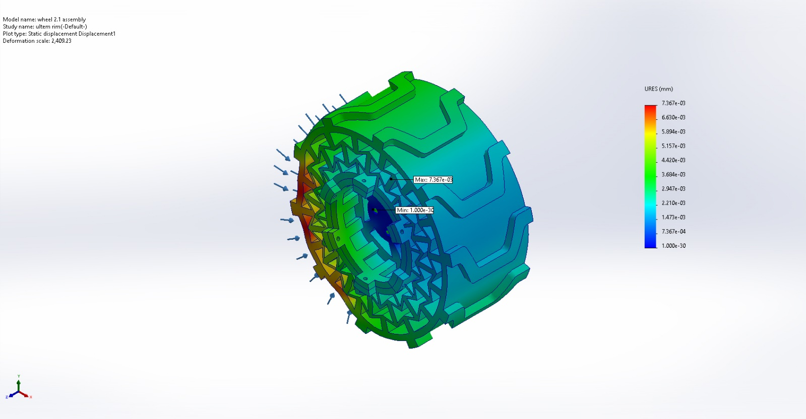
wheel 2.1 assembly-ultem rim-Displacement-Displacement1

Name | Type | Min | Max
Strain1 | ESTRN: Equivalent Strain | 2.569e-08  Element: 33696 | 9.435e-05  Element: 35338
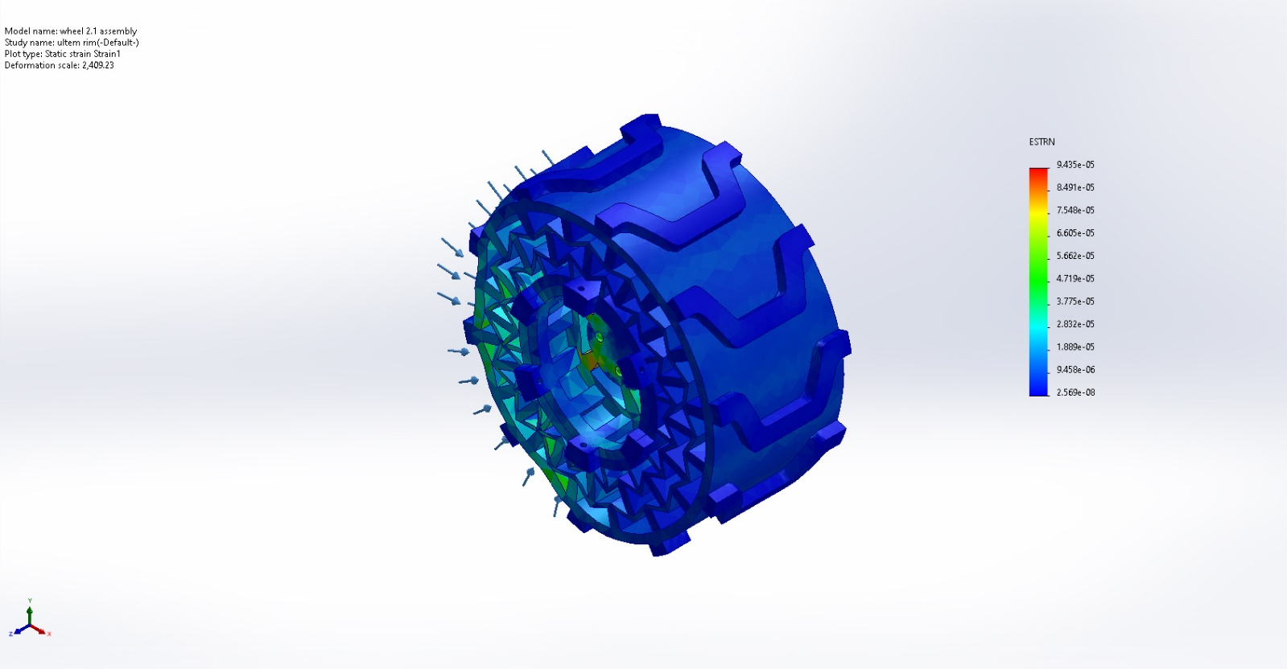
wheel 2.1 assembly-ultem rim-Strain-Strain1

Conclusion

